**PHYS 121 Labs**

**Pohl’s Pendulum**

# Introduction

Oscillation refers to a repetitive variation of a system about an equilibrium point over time. When the motion is mechanical, it is often termed **vibration**. Common examples include a swinging pendulum, a vibrating guitar string, or a playground swing. Even electrical systems, such as alternating current, exhibit oscillatory behavior.

In this experiment, we investigate the **rotational oscillation** of a wheel (Pohl’s pendulum) to explore key concepts of harmonic motion. We will study different types of oscillations—**free**, **damped**, and **forced**—and analyze how the system responds under varying conditions.

**Goals**

## 1.Free and damped oscillation

(i) Determine the amplitude and natural frequency of undriven motion.

(ii) Measure the period and calculate the damping coefficient for different damping settings.

## 2.Forced oscillation

(i) Observe the **stroboscopic effect** and use it to analyze the **phase shift** between the pendulum and the external driving torque.

(ii) Record resonance behavior and plot **resonance curves**.

# Theory

A **free oscillation** occurs when a system is displaced and allowed to oscillate without external influence. If the restoring torque is proportional to the displacement, the motion is approximately **harmonic**, and the system oscillates sinusoidally.

In real systems, **friction** causes energy loss over time, resulting in **damped oscillations**, where the amplitude gradually decreases. The degree of damping depends on the system's resistance to motion.

When a periodic external force is applied, the system exhibits **forced oscillation**. If the driving frequency approaches the system’s natural frequency, the amplitude increases significantly—a phenomenon known as **resonance**. The system's response depends on the relationship between driving frequency, damping, and natural frequency.

By analyzing the rotational motion of Pohl’s pendulum, this lab provides hands-on insight into these fundamental oscillatory behaviors.

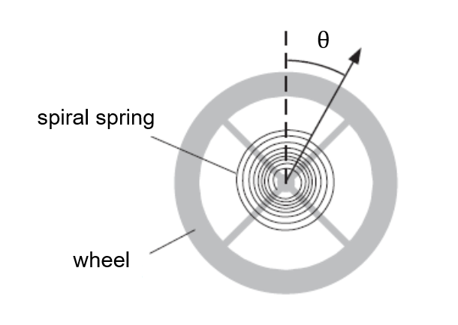

Figure 1 The rotating pendulum

A sketch of this pendulum is shown in Figure. 1. A metallic wheel is mounted such that it may rotate around its center axis. A spiral spring ensures that the wheel, once rotated out of its equilibrium position, experiences a restoring torque. If the pendulum is deflected by a small angle $θ$ out of equilibrium, the restoring torque $M_{s}$ is approximately proportional to $θ$ and becomes:

|  |  |  |
| --- | --- | --- |
|  | $$M_{s}=-kθ$$ | (1) |

where $k$ is the stiffness coefficient of the spiral spring.

Neglecting damping/external forces, we can deduct from Newton’s second law for rotation:

|  |  |  |
| --- | --- | --- |
|  | $$I\frac{d^{2}θ}{dt^{2}}=-kθ$$ | (2) |

where $I$ is the moment of inertia of the pendulum.

Equation (2) represents the differential equation describing a harmonic oscillator with the solution

|  |  |  |
| --- | --- | --- |
|  | $$θ(t)=θ_{0}cos⁡(ω_{0}t-φ)$$ | (3) |

where $θ_{0}$ is the oscillation amplitude, $ω_{0}=\sqrt{\frac{k}{I}}$ is the angular frequency of the free oscillator, and $φ$ is the phase shift/initial phase.

The angular frequency $ω_{0}$ is given by the properties of the oscillator. It determines the oscillation period $T_{0}$

|  |  |  |
| --- | --- | --- |
|  | $$T_{0}=\frac{2π}{ω_{0}}$$ | (4) |

The amplitude $θ_{0}$ and the phase $φ$ are determined by the starting/initial conditions.

As shown in Figure 2 the deflection is passing through extremal positions at times $ω_{0}t-φ=0, π, 2π,…, nπ$, the amplitude of these oscillations remains constant.

Figure 2 Free oscillation

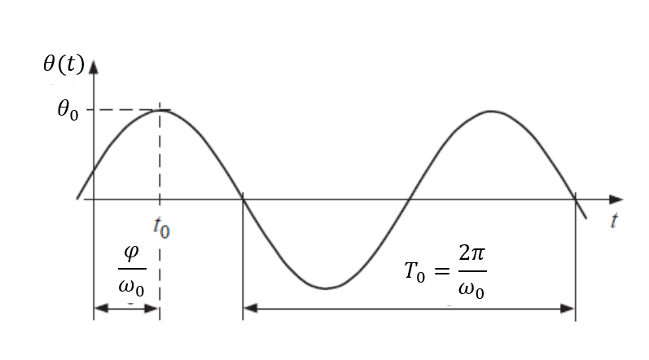

## Damped oscillation

The oscillation of the pendulum is said to be damped if frictional/drag forces act on the pendulum in the direction opposite to its movement. If the torque $M_{d}$ produced by the frictional/drag forces is proportional to the angular velocity, we may write

|  |  |  |
| --- | --- | --- |
|  | $$M_{1}=-b\frac{dθ}{dt}$$ | (5) |

where $b$ is the friction/drag parameter.

The Newton’s second law for rotation yields

|  |  |  |
| --- | --- | --- |
|  | $$I\frac{d^{2}θ}{dt^{2}}=-kθ- b\frac{dθ}{dt}$$ | (6) |

Or

|  |  |  |
| --- | --- | --- |
|  | $$\frac{d^{2}θ}{dt^{2}}+\frac{b}{I}\frac{dθ}{dt}+ \frac{k}{I}θ=0$$ | (7) |

This is the differential equation of a damped oscillation. The solution depends on the strength of the damping.

For weak damping the solution becomes

|  |  |  |
| --- | --- | --- |
|  | $$θ(t)=θ_{1}e^{-βt}cos⁡(ω_{1}t-φ_{1})$$ | (8) |

where $β=\frac{b}{2I}$ is the damping coefficient, $θ_{1}$ is the maximum amplitude, $ω_{1}=\sqrt{{ω_{0}}^{2}-β^{2}}$ is the angular frequency of the damped oscillation, and $φ_{1}$ is the phase constant.

The angular frequency $ω_{1}$ is smaller than the angular frequency $ω_{0}$ of the undamped oscillator. This means that the oscillation is slowed down by the damping. The phase constant $φ_{1}$ and the maximum amplitude $θ_{1}$ are determined by the starting conditions.

The deflection passes through extrema at times $ω_{1}t-φ_{1}=0, π, 2π,…, nπ$. The amplitude

|  |  |  |
| --- | --- | --- |
|  | $$θ(t_{n})=θ_{1}e^{-βt}$$ | (9) |

decreases exponentially with time, the stronger the damping the faster the amplitude decays. The decay time $τ=β^{-1}$ equals the time interval after which the amplitude decays to $e^{-1}$ of its initial value.

Figure 3 Oscillation with weak damping

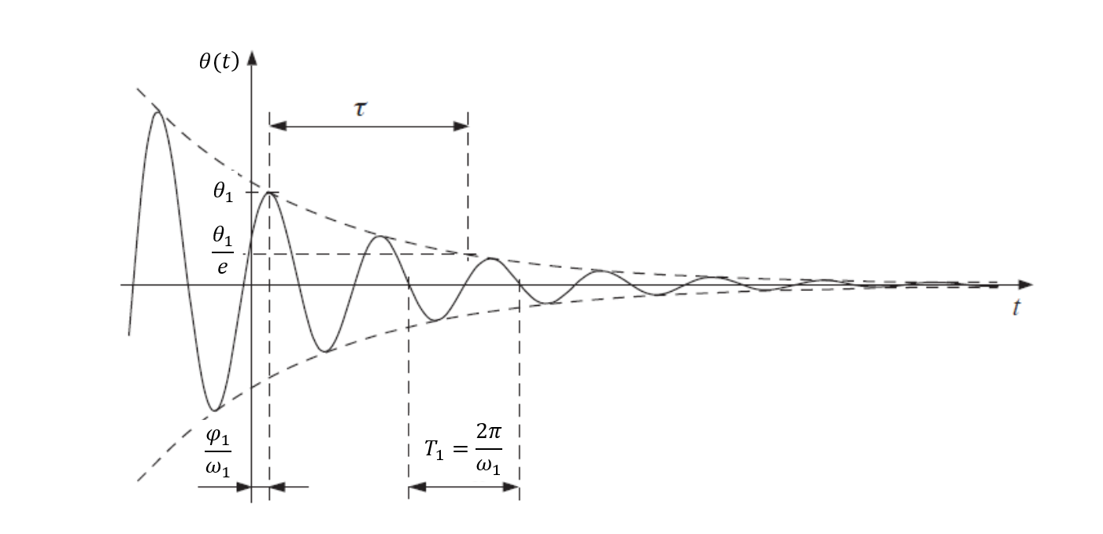

As can be seen from $ω_{1}=\sqrt{{ω_{0}}^{2}-β^{2}}$, $ω_{1}$ decreases with increasing damping $β$. In the case of strong damping $β>ω_{0}$ the motion is no longer periodic but the pendulum returns to its initial equilibrium position without overshooting. The limiting case of $β=ω_{0}$ or $ω_{1}=0$, which marks the transition between damped oscillation and aperiodic motion, is called critical damping. The case of critical damping is important for technological applications like buffers, vibration dampers, or in weighing scales or galvanometers. What is the difference in behaviors between strong damping and critical damping?

## Forced oscillation

If an additional torque $M_{2}$, produced by an external force of angular frequency $ω_{2}$, acts on the pendulum

|  |  |  |
| --- | --- | --- |
|  | $$M_{2}=M_{0}cos⁡(ω_{2}t)$$ | (10) |

where $M_{0}$ is the amplitude of the external torque.

The Newton’s second law for rotation leads to the following differential equation of a forced oscillation:

|  |  |  |
| --- | --- | --- |
|  | $$\frac{d^{2}θ}{dt^{2}}+\frac{b}{I}\frac{dθ}{dt}+ \frac{k}{I}θ=\frac{M_{0}}{I}cos⁡(ω_{2}t)$$ | (11) |

Or

|  |  |  |
| --- | --- | --- |
|  | $$\frac{d^{2}θ}{dt^{2}}+2β\frac{dθ}{dt}+ ω_{0}^{2}θ=F_{0}cos⁡(ω_{2}t)$$ | (12) |

where $F_{0}=\frac{M_{0}}{I}$ is the magnitude of the external force.

The solution of Equation (12) is

$θ=θ_{1}e^{-βt}\cos\left(ω_{1}t-φ_{1}\right)+θ_{2}cos⁡(ω_{2}t-φ_{2})$ (13)

In the beginning, the damped oscillation (1st part of equation 13) at angular frequency $ω_{1}$ and the forced oscillation (2nd part of equation 13) at angular frequency $ω_{2}$ are superimposed. The damped oscillation decays with time, but the forced oscillation remains for times $t≫β^{-1}$. As a result (after a ‘long’ time), the pendulum will oscillate with certain phase lag with respect to the driving force and at driving angular frequency $ω_{2}$. Using the ansatz

|  |  |  |
| --- | --- | --- |
|  | $$θ(t)=θ_{2}cos⁡(ω_{2}t-φ_{2})$$ | (14) |

together with Equation (12), we can show that the amplitude $θ_{2}$ of the forced oscillation behaves like

|  |  |  |
| --- | --- | --- |
|  | $$θ_{2}=\frac{F_{0}}{\sqrt{{\left({ω_{0}}^{2}-{ω_{2}}^{2}\right)}^{2}+4β^{2}ω_{2}^{2}}}$$ | (15) |

Furthermore,

|  |  |  |
| --- | --- | --- |
|  | $$φ_{2}=\tan^{-1}\left(\frac{2βω_{2}}{{ω_{0}}^{2}-{ω_{2}}^{2}}\right)=\tan^{-1}\left(\frac{βT_{0}^{2}T}{π\left(T^{2}-{T_{0}}^{2}\right)}\right)$$ | (16) |

Figure. 4. shows the amplitude and phase shifting of forced oscillation for different damping.

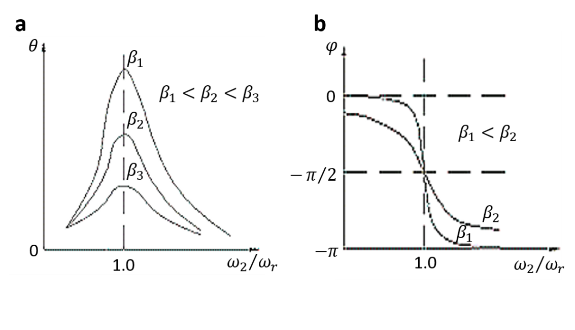According to Equation (15), $θ_{2}$ is maximum when $ω_{2}=ω_{0}$, which results in resonance. When resonance occurs, the peak maximum $ω_{r}$ is located at

Figure 4 Forced oscillations with different $β$

|  |  |  |
| --- | --- | --- |
|  | $$ω_{r}=ω_{0}$$ | (17) |

and the corresponding amplitude $θ_{max}$ amounts to

|  |  |  |
| --- | --- | --- |
|  | $$θ_{max}=\frac{M_{0}}{bω_{0}}=\frac{F_{0}}{2βω_{0}}$$ | (18) |

An analysis of equations (14) and (15) gives evidence of the following, when the frequency of the driven force is given:

1. The greater $F_{0}$, the greater $θ_{2}$
2. The greater $β$, the smaller $θ_{2}$

# Experiment set up and procedure

In this lab, we use a modified version of the Pohl’s pendulum (originally designed by Robert Wichard Pohl (1884-1976)) which consists of an oscillation unit and an electronic control unit.

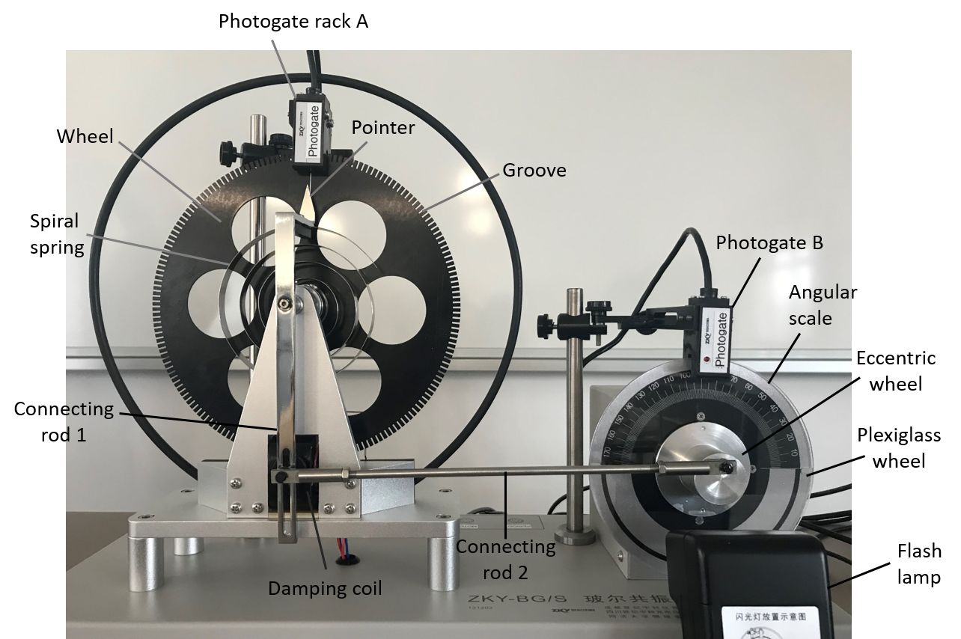**Oscillation unit**

Figure 5 Oscillation Unit

A copper rotating wheel is mounted on a rack, which is driven by an electric motor and damped by a damping coil (Figure. 5). The electric motor and the rotating wheel are connected mechanically by an eccentric wheel and two rods. One end of the spiral spring is connected to the shaft of the rotating wheel and the other end is attached to the connecting rod. The spiral spring ensures that the wheel, once rotated out of its equilibrium position, experiences a restoring torque. The damping coil is beneath the rack with the rotating wheel. Magnet fields are generated when a current is passing through the coil. Due to electromagnetic induction, when the rotating wheel cuts magnetic field lines, it is subject to an electromagnetic damping force (this part will be discussed in PHYS 122). The motor produces a periodic torque, whose frequency is controlled via the frequency of the motor.

Short grooves are distributed evenly at the edge of the rotating wheel. The angle between two short grooves is 2 ͦ. There is a deep groove marked with a white line on the wheel, which should be aligned with the pointer when the wheel is at the equilibrium position.

Two photogates are mounted on the photogate rack A. One of them is used to measure the period of oscillations by detecting the frequency of the deep groove passing through the gate. The deep groove (Figure. 6) passes through the photogate twice during each oscillation period. The other one is used to measure the amplitude of the oscillations by detecting the number of the short grooves passing through it.

An eccentric wheel is mounted on the motor shaft through a connect-rod mechanism to drive the rotating wheel. A Plexiglass wheel marked with a white line is mounted on the motor shaft and rotates with the motor. The phase shift $φ$ can be read out on the angular scale. The rotation speed of the motor can be precisely adjusted within a range of 30–45 cycles per minute by the control unit. Photogate B is mounted above the motor, which measures the period of the external torque by detecting the frequency of the white line passing through it.

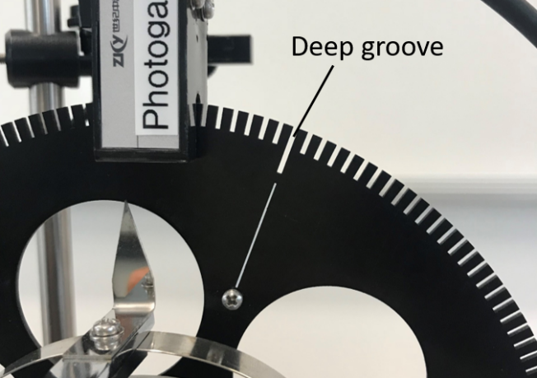

Figure 6 Location of the deep groove

When forced oscillation occurs, the phase shift between the rotating wheel and the external force is measured with assistance of a flash lamp. The flash lamp is controlled by photogate rack A detecting the deep groove. When the deep groove passes through the equilibrium position (rack A?), a flash is triggered. When the forced oscillation reaches a steady state (the damping part is almost gone?), the white line on the Plexiglass wheel appears to be pointing exactly to the same value on the angular scale viewed under the flash. This phenomenon is called stroboscopic effect. In fact, the Plexiglass wheel is rotating at a constant rate.

**Electronic control unit**

Figure 7 Electronic control unit

1. LCD screen, 2. Arrow keys, 3. Enter key, 4. Reset key, 5. Power key, 6. Flash key, 7. Motor period key

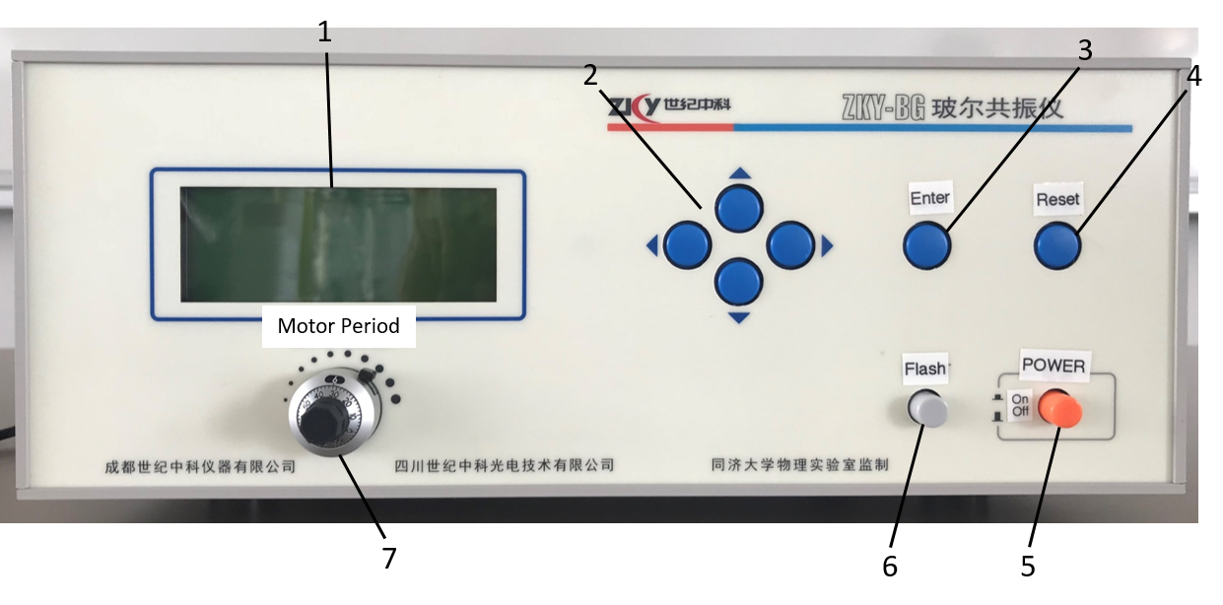

Figure. 7 shows the electronic control unit for the oscillation system. The “Motor Period” key controls the period of external torque. The damping coefficient of the pendulum can be changed by varying the current passing through the damping coil. There are three different levels of damping including “Damp1”, “Damp2” and “Damp3” (Figure. 10a). The “Flash” key is used to control the flash lamp. The flash lamp should ONLY be switched on when reading the phase shift.

The functions of “◀”, “▶”, “▲”, “▼” and “Enter” keys are present on Figure 8a.

## Before measurement

1. Press “POWER” to turn on the control unit.
2. To change the language, select “English” using “▶” and press “Enter”. A screen demonstrating the key functions should appear (Fig.8a)
3. Press “Enter” and select “Local” for the system mode using “▶” and press “Enter” to confirm the selection. A screen demonstrating the “Test Procedure” should appear (Fig. 8b).

**Note:**

* DO NOT keep the pendulum oscillating without damping or with a very weak damping for a long time. (Why?)

## Free oscillation (Each group member should do it separately)

## In this section, you will need to determine the amplitude $θ$ and the natural period $T$ of free oscillations.

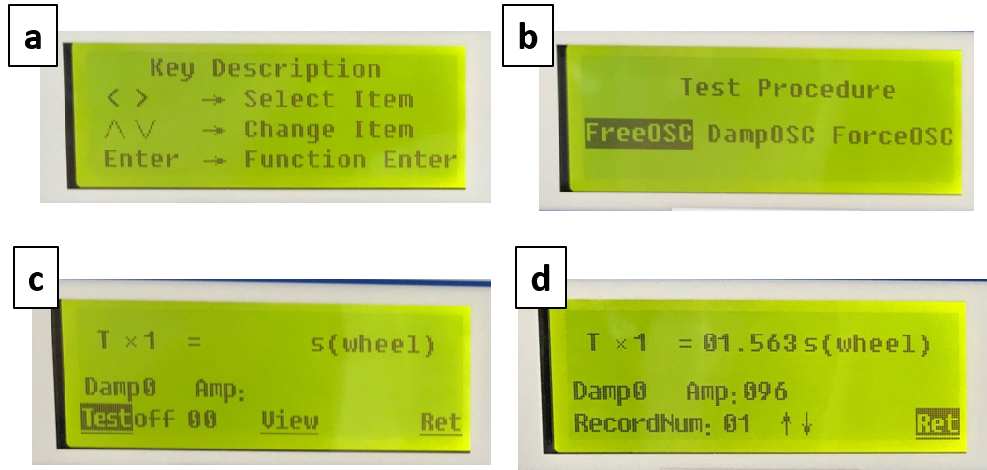

Figure 8 LCD screens for free oscillation measurement

1. When you get to the screen as shown in Fig. 8b, “FreeOSC” is selected by default. Press “Enter” to confirm your selection.
2. Initially, it has to be ensured that the pendulum pointer points vertically while line A or B (Fig. 9) aligns with zero degree of the angular scale. This can be achieved by turning the eccentric wheel of the motor.
3. Rotate the wheel approximately 160 ͦ with your hand carefully. Release the pendulum quickly without friction of your hand.
4. To start recording data, press “▲” or “▼” and the “Test” mode is switched from “off” to "on”. The valid range for recording amplitudes is 160 ͦ − 50 ͦ. When $θ$ *<* 160 ͦ “Test” is switched “on”; and when $θ$ *<* 50 ͦ “Test” is switched “off” automatically.
5. When the measurement completes, “Test off” appears and the recorded data are saved.
6. To access the data view screen (Fig. 8d) select “view” using “◀” or “▶” and press “Enter”. Press “▲” or “▼” to go through all recorded data. The *T* × *N* means N times of period T.
7. Draw a table similar to Table 1 in your lab notebook and fill out the table with your data.

**Note:**

Figure 9 Eccentric disc

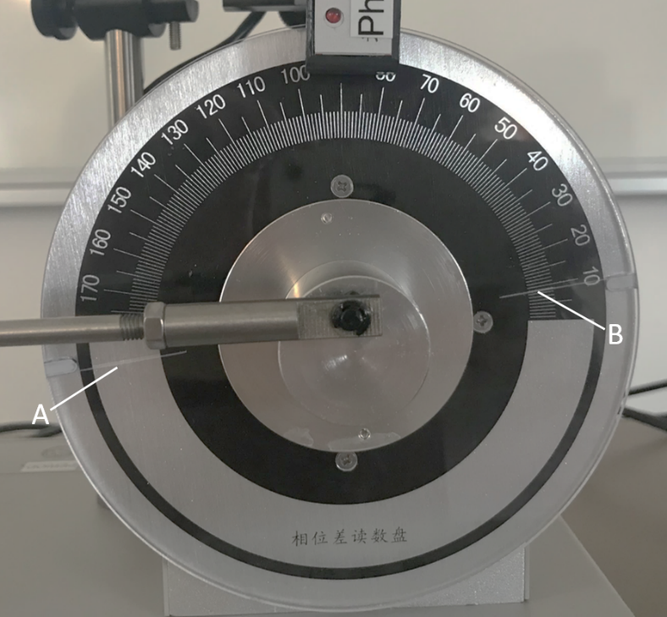

* In the “FreeOSC” mode, the system only records the corresponding amplitude when the oscillation period is changing. Therefore, the system sometimes only records once when the wheel oscillates more than once, i.e. the deep groove passes through the photogate for several times (incorrect reading of the period?). It may occur that some amplitude data (the data set of a certain amplitude?) is deleted automatically when you view the data.
* Initially, it has to be ensured that the pendulum pointer at rest coincides with the zero-position of the scale. This can be achieved by turning the eccentric wheel of the motor to align line A or B (Fig 9) with zero position of the angular scale. The FreeOSC setup must align the pendulum with the angular zero-position to ensure that subsequent ForcedOSC data (especially phase difference) are measured correctly and consistently.

## Damped oscillations (Each group member should do it separately with all damping levels)

In this section, you will need to determine the damping coefficient $β$ of damped oscillations

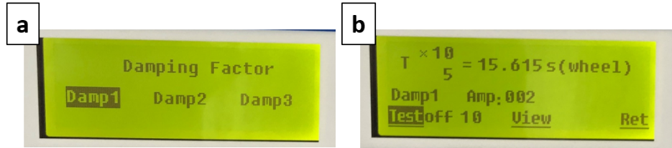

Figure 10 LCD screens for damped oscillation measurement

1. Select “Ret” and press “Enter” to return to the “Test Procedure” screen (Fig.8b). Select “DampOSC” using “▶” and press “Enter” to change to the damped oscillation mode.
2. There are three different damping levels, where “Damp1” is the lowest. “Damp1” is selected by default (Fig. 9a). Press “Enter” to confirm your selection.
3. Rotate the wheel approximately 160 ͦ with your hand and release it.
4. To start recording data, press “▲” or “▼” and the “Test” mode is switched from “off” to "on”. After recording 10 sets of data, the system automatically switches to “Test off” and stops collecting data though you may see the value of amplitude changing on the screen.
5. Draw a table similar to Table 2 in your notebook and fill out it with data as required.
6. Repeat steps 2 - 5 for “Damp2” and “Damp3” levels. You should prepare tables similar to Table 2 for the data acquired with these two levels.
7. After each measurement, read the amplitudes of damped oscillation $θ_{1}$, $θ_{2}$, $θ_{3}$, …, $θ_{n}$ and calculate the damping coefficient $β$ using the following formula:

|  |  |  |
| --- | --- | --- |
|  | $$\ln{\frac{θ_{0}e^{-βt}}{θ_{0}e^{-β\left(t+nT\right)}}}=nβ\overline{T}=\ln{\frac{θ_{0}}{θ_{n}}}$$ | (19) |

where $n$ is the number of oscillation periods, $θ_{n}$ is the amplitude of the $n^{th}$ oscillation, $\overline{T}$ is the average period of the oscillations.

**Note:**

• DO NOT change/touch? the damping level while the measurement is running.

## Forced oscillations (Student A uses one damping level and Student B uses another. Share the data when conducting data analysis)

This section must be carried out after selecting the damping mode in **Damped oscillations**, otherwise you will not be able to continue the measurement. Selecting the damping mode is essential because it defines how the system drives the pendulum, how it evaluates the steady state, and how it stores and processes the measurement data. Without it, forced oscillation measurements cannot proceed

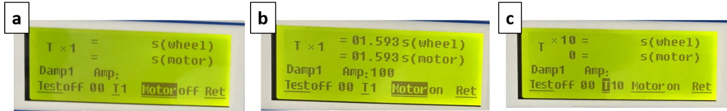

Figure 11 LCD screens for forced oscillation measurement

1. Return to the “Test Procedure” screen as shown on Fig.8b. Select “DampOSC” using “▶” and press “Enter” to change to the damped oscillation mode. Select “Damp1” and press “Enter”.
2. Return to the “Test Procedure” screen as shown on Fig.8b. Select “ForceOSC” and press “Enter” to change to the forced oscillation mode.
3. As shown in Fig 11a “Motor” is selected by default. Press “▲” or “▼” to turn on the motor. Keep using “T1” for the period. When the oscillation amplitude of the wheel becomes stable and the period difference between the wheel and motor is less than 0.001 s, the system is considered to be in a steady state (Fig.11b). You can then start the measurement.
4. Before starting your measurement, you will need to change the period from “T1” to “T10” in order to reduce the measurement error. To do it, select “T” and use “▲” or “▼” to change the number from “1” to “10” (Fig. 11c). Then select “Test” and press “▲” or “▼” to change it from “off” to "on”, and the control unit starts recording data.
5. Upon completion of one measurement, “Test off” appears and the oscillation amplitude can be viewed on the screen. Determine the phase shift $φ$ between the wheel and the external torque using the flash lamp. To do that, place the flash lamp in front of the Plexiglass wheel and press “Flash” when measuring the phase shift. Find out the value indicated on the angular scale when it is viewed under the flash (stroboscopic effect) and record the value as $φ_{2}$ in Table 3.

|  |
| --- |
| Tips:  To read the indicated value on the angular scale when the flash lamp is on, it is recommended to observe line A or B in the inner (black) part of the angular scale. |

1. Change the period of motor by tuning the “Motor period” knob that adjusts the rotation speed of the motor (i.e. the angular frequency $ω_{2}$ of the external torque). This results in a change in the phase shift $φ$ between the wheel and motor. Each adjustment in the rotation speed of the motor shall correspond to $∆φ≈10°$ (because of the pre-set ‘Moter period’). For instance, the phase shift observed for the initial motor period is $φ_{1}=70$ ͦ. After changing the motor period, the phase shift observed is $φ_{2}=60$ ͦ. Then $∆φ= φ_{1}-φ_{2}=10°$.
2. Each time when you change the motor period, wait until the system returns to steady state (approximately 2 min), and then you can record a new set of data including the motor period, amplitude and phase shift.
3. Change the motor period in small steps when the angular frequency is in the vicinity of the resonance.
4. Prepare a table similar to Table 3 in your notebook and fill out it with your data.
5. Repeat steps 1 - 9 for “Damp2” or “Damp3” mode. You should prepare tables similar to Table 3 for the data acquired with these two modes.

**Note:**

* You must run the measurement for at least 10 sets of data when changing the motor period. The data must include the values when the motor period is the same as the period of free oscillations.
* The flash may interrupt the data collection by the photogate. Therefore, you should read the phase shift with the flash lamp ONLY when the data collection completes and “Test off” appears on the screen.

**After measurement**

1. Press and hold “Reset” until the screen turns blank. All data are deleted when you reset the system.
2. Press “POWER” to turn off the system.

**Data collection and analysis**

You should keep all raw data including units in your lab notebook. Below shows examples of how you should record your data in your lab notebook. The raw data, data analysis, answers to the questions should all be included in the lab report.

1. **Correlation between the natural period $T_{0}$ of the pendulum and the amplitude $θ_{0}$ of free oscillation**

**Table 1**: Correlation between the natural period $T_{0}$ of the pendulum and the amplitude $θ_{0}$ of free oscillation

|  |  |
| --- | --- |
| Amplitude $θ_{0}$ | Period $T_{0}$ (s) |
|  |  |
|  |  |
|  |  |
|  |  |
|  |  |
|  |  |
|  |  |

(i) Make a plot with natural period $T_{0}$ as *y* axis and amplitude $θ_{0}$ as *x* axis.

(ii) Linear fit the data of $θ_{0}$ v.s. $T_{0}$. (Then you can use the fitted line to evaluate the natural period *T*0 of different amplitude $θ_{0}$).

1. **Calculation of damping coefficient $β$**

Based on Equation 19, we can calculate the damping coefficient $β$ with

|  |  |  |
| --- | --- | --- |
|  | $$5β\overline{T}=\ln{\frac{θ_{i}}{θ_{i+5}}}$$ | (20) |

**Table 2**: Amplitude of different oscillation periods in the damped mode.

**Damping Level** _______

|  |  |  |  |  |
| --- | --- | --- | --- | --- |
| Amplitude # | Amplitude $θ$ ( ͦ ) | Amplitude # | Amplitude $θ$ ( ͦ ) | $$\ln{\frac{θ_{i}}{θ_{i+5}}} (After lab)$$ |
| $$θ_{1}$$ |  | $$θ_{6}$$ |  |  |
| $$θ_{2}$$ |  | $$θ_{7}$$ |  |  |
| $$θ_{3}$$ |  | $$θ_{8}$$ |  |  |
| $$θ_{4}$$ |  | $$θ_{9}$$ |  |  |
| $$θ_{5}$$ |  | $$θ_{10}$$ |  |  |
| (After lab) |  | Average of $\ln{\frac{θ_{i}}{θ_{i+5}}}$ |  |  |
| (After lab) | Damping coefficient $β$ ( equation 20) | | |  |

10 $T$ = _____ s; $\overline{T}$ = _____ s

1. **Measurement of amplitude and phase shift of forced oscillation**

**Table 3**: Amplitude $θ$ and phase shift of forced oscillation with different natural period *T*0 of the pendulum

**Damping Level** _______

|  |  |  |  |  |  |
| --- | --- | --- | --- | --- | --- |
| Measurement | | | Calculation (After lab) | | |
| Motor period  T (s) | Phase shift $φ_{2}$ (◦) | Amplitude $θ$ (◦) | Corresponding $T_{0}$ (according to the fitted line of free oscillation) | $$\frac{ω}{ω_{r}}$$ $(ω=2π/T$, $$ω_{r} from equation17)$$ | $${φ_{2}'=tan}^{-1}\left(\frac{-βT_{0}^{2}T}{π\left(T^{2}-{T_{0}}^{2}\right)}\right)$$ |
|  |  |  |  |  |  |
|  |  |  |  |  |  |

(i) Make a plot with $θ$ as the dependent values and $\frac{ω}{ω_{r}}$ as the independent values for different damping levels. All data should be plotted in ONE graph.

(ii) Find corresponding period T0 for different amplitude $θ$ based on the fitted line of free oscillation and calculate $φ_{2}$’ with Equation 16

(iii) Make a plot with $φ_{2 }$ and $φ_{2}$’ as the dependent values, $\frac{ω}{ω_{r}}$ as the $independent values$. All data should be plotted in ONE graph.

## *Questions*

*You should include the answers to the following questions in the lab report.*

1. *Can we use the data obtained for free oscillation to calculate the damping coefficient $β$ with Equation (20)? If yes, please show it? If no, why not?*
2. *Give two simple examples of the resonance phenomenon, one of them is good for our life and give a solution on how to make use of it, while the other example is bad for our life and give a solution on how to avoid it. (involve AI tools?)*